UNIDAD 6

Las citas. Estructuras y recursos para el posicionamiento del autor en el campo. Procesos verbales y mentales. Citas directas. Citas indirectas. Citas integrales y no integrales. Algunos aspectos éticos de la ciencia. Plagio.

Why do you think researchers cite the work of other researchers?

Read the following reasons carefully and decide which, in your opinion, are possible reasons for including citations in the introductions of research articles.

Researchers include citations in their papers:

- For ethical reasons
- To show familiarity with the work of others
- To make the text more persuasive
- As a form of reward to other researchers
- To establish a research territory

Let us locate citations within the cycle of knowledge production
(Berkenkotter and Huckin, 1995)

Citation methods

A)
More recent studies indicate that smaller particles,
such as PM2.5 (mass median diameter o2.5 mm) may be
more closely linked with health effects (Schwartz et al.,
1996).

B)
Population genetic studies of Ae. aegypti conducted over
the last 30 years have defined genetic relationships among
collections worldwide1,7–11 and more recently have focused
on local patterns of dispersal.12,13

C)
KISSPEPTINS ARE PRODUCTS of the Kiss1 gene1 that
bind to the G protein-coupled receptor (GPR)54 (1–3).
KiSS-1 and GPR54 are widely distributed in the forebrain
(4–6), but their physiological function has only recently begun

to emerge.

D)
Canadian provinces, the aphid has
become established as an economically important
pest of soybeans, Glycine max (L.) Merr.1 Soybean
aphid is native to the temperate regions of Asia,
where it is suppressed by numerous parasitoids and
predators.2 In China, coccinellids are thought to
play a key role in suppression of soybean aphid
populations owing to high predation rates and
abundance in soybean fields.3

E)
Nanostructured materials with pore sizes in the mesoporous
range (2–50 nm from the IUPAC definition) have received
much attention, especially in relation to their potential use in
applications ranging from batteries[1] to biosensors.[2] It…

Citation structures (In-text citations)

There are different ways to cite the work of others in the text of the research article:

- Smith (2010) demonstrated that….

- According to Smith (2010), the weight of…….

- The weight of xxx was higher, as shown by Smith (2010)

- Different authors have shown that… (Smith, 2010; James, 2011)

- Recent studies have analysed…(Smith, 2010; James, 2011)

- The growth of xxx is higher under xx conditions (Smith, 2010; James, 2011)

The author may be cited by:

- Explicitly mentioning the last name in the sentence and giving the year of the publication in parentheses immediately afterwards. This method highlights the author(s) as well as reports the results.

Flanagan and FitzGerald (2002) found that the order of TGase cross-linking had a significant effect on the nitrogen solubility of sodium caseinate.

More specifically, on the basis of the results reported by Parr et al. (2002), novices' olfactory recognition was expected to be compromised when they had been instructed to name the odorants during the learning phase of the recognition task.

TIPO 1: AUTORES INTEGRADOS EN EL TEXTO

- Referring to the author’s work ( study, report, survey, work, findings, results) and then giving the first author’s last name and the year of publication in parentheses at the end of the sentence. This method focuses the reader’s attention on the study while acknowledging the researcher(s).

TIPO 2: ESTUDIOS O GRUPOS MENCIONADOS EN EL TEXTO

Although a number of experiments have demonstrated modification of canopy inputs by insect herbivores (e.g., Kimmins 1972; Ohmart et al. 1983; Fogal and Slansky 1985; Grace 1986; Hollinger 1986; Risley and Crossley 1988; Lightfoot and Whitford 1990; Stadler and Michalzik 2000), few have addressed the effects of these modified inputs on the soil subsystem or plant growth (Seastedt et al. 1983; Schowalter et al. 1991; Lovett and Ruesink 1995; Belovsky and Slade 2000; Reynolds and Hunter 2001; Chapman et al. 2003; Hunter et al. 2003).

- Simply referencing the author(s) and year of publication(s) in parentheses at the end of the sentence. Again, this focuses the reader’s attention on the results and acknowledges the results; it is the least author-prominent.

Chlorosis in young leaves is frequently observed on plants irrigated with water of high alkalinity, which may also inhibit growth of sensitive plants through reduced root growth and/or nutrient uptake and utilization (Alhendawi et al., 1997).

3 AUTORES NO INTEGRADOS EN EL TEXTO

Activity A

Read the following examples of in-text citations.
To which category do they correspond?

 | Example | Category
 | There has been growing interest in mixed emotions over the past two decades (e.g., Aaker, Drolet, & Griffin, 2008; Kreibig, Samson, & Gross, 2013;Larsen, McGraw, & Cacioppo, 2001; Russell & Carroll, 1999; Williams & Aaker, 2002).
 | In other studies, the percentage recovery of EPN species has varied from 0.7 to 70.1% (Mra´cˇek & Becva´ r, 2000; Bruck, 2004).
 | Ippolito,Fernandes & Holtsford (2004) investigated the role of ﬂoral traits in maintaining the species boundary between the wild tobacco species Nicotiana alata and Nicotiana forgetiana.
 | The detection and identi- ﬁcation of indigenous EPN isolates is of major importance, due to differences in strain virulence against natural and local insect pests, environmental conditions that may affect their survival and reproductive potential (Stock, 2009).
The recovery rates of both Steinernema spp. and H. bacteriophora are similar to those of other studies in the Mediterranean area: 1.3% Heterorhabditis and 22% Steinernema in Catalonia (Garcı´a del Pino, 2005), and 5.3% Heterorhabditis and 8.5% Steinernema in Italy (Tarasco
& Triggiani, 1997).
 | Hippocampal primary cultures were prepared from CD1 mice as described [Martel et al., 2008].
 | Pollinator discrimination of ﬂoral traits also has been hypothesized to contribute to reproductive isolation between related plant species (Grant 1994).
 | Few studies have investigated this aspect of ﬂoral shape (see Herrera 1993a,b; Go´mez et al. 2008a; Nattero, Cocucci & Medel 2010).
 | Finer spatial and temporal manipulations of ﬂoral stimuli have revealed that visual cues are critical for the ﬁnal stages of ﬂoral approach and proboscis extension (Goyret, Markwell & Raguso 2007; Balkenius & Dacke 2010).
 | Although several recent TR docking studies utilized AutoDock 499,130 or earlier generations of AutoDock and/or FlexX,131,132 given the large conformational flexibility and number of rotatable bonds of our inhibitors, AutoDock Vina was the obvious choice for our studies.

Activity B

Put a check in front of the verbs that would be used to report others’ research.

find | consider | report | produce | have
report | store | hypothesize | measure | describe
mix | claim | assume | weigh | boil
analyze | suggest | show | argue | observe
Indicate | Carry out | appear | calculate | demonstrate

Let’s go back to the Introduction section of the model text. We will observe how the authors cited the work of others.
We will also observe whether reporting verbs were used.

Expressing Attitude through Choice of Verb and Tense

It is possible to express Attitude through Choice of Verb and Tense

When we use someone else’s words, we may quote the exact words or reproduce them by paraphrasing or synthesizing what they said. In addition to using their ideas, and sometimes words, we also position ourselves with regard to what they said. This means that we can agree or disagree with those words; we can show our attitude about them. The verb we use to report other researchers’ ideas plays a central role in the expression of position.

Suppose that the teacher said, “You will have the exam on Monday” and you want to communicate this to your friends. You can do so in a variety of ways. Note the effect of using different reporting verbs:

The teacher said that we would have the exam on Monday.
The teacher threatened that we would have the exam on Monday.
The teacher promised that we would have the exam on Monday.
The teacher agreed to have the exam on Monday.
The teacher shouted that we would have the exam on Monday.
The teacher ordered us to have the exam on Monday.

Attitude conveyed by the choice of the verb in research articles

Positive

More recently, a culture system that reproduces the main characteristics of FAE and M cells by cultivation of murine PP-derived lymphocytes with human intestinal cells has been established (7).

By choosing ‘established’, the writer of this sentence tells the readers that he/she agrees with the work that the other researcher reported.

Neutral

In children the role of CCR5 in transmission of disease progression has been assessed in cross-sectional studies of children born to mothers seropositive for HIV-1.

The verb ‘assessed’ states clearly and directly that something has been evaluated, nothing more and nothing less. The reader cannot detect the writer’s attitude about this piece of information.

Neutral to Negative

This adaptor-mediated recruitment is believed to be sufficient for caspase activation (8).

By using ‘is believed to be’, the writer is distancing himself from this piece of information. It says that the writer is not convinced that this information states a truth.

Activity C

Several examples of reporting verbs have been presented previously. Here is a list of some that are commonly used in the biological sciences. What attitude do they convey?

suggest | demonstrate | find | observe
argue | describe | focus on | point out
assess | believe | hypothesize | pose
believe | establish | identify | propose
claim | evaluate | note | prove
conclude | examine | notice | question
recognize | report | show

Activity D

Return to the verbs we identified in the Introduction sections of the papers analyzed. Decide if they express a positive (P), neutral (N) or neutralnegative (NN) attitude to the cited research

Other verbs used to say what others did

conduct/carry out (a study)
provide an account
make (a comparative study)
produce (a critique)
study
investigate
develop (a theory)
extend (someone's idea)
make the point that
highlight
identify
introduce (the concept, point, ...)
emphasise
devise /propose (a method, a technique, ...)

Tense in Reporting Verbs

Present tense
The present tense is used when establishing the territory, particularly when claiming centrality and making topic generalization, steps 1 and 2 of Move 1 of the Introduction. In general, these generalizations are not referenced, indicating that the knowledge presented is part of the shared knowledge of the science.
Also, if the work cited is considered to be accepted or established, generalized knowledge, writers will write the verb in simple present tense.

Example 1: One possible neural architecture for achieving integrated spatial behavior is the construction of multimodal spatial representations that can provide signals in several frames of reference, thus allowing generation of different types of motor behavior [1 and 2].

Present perfect tense

If various researchers have addressed the same problem, and the knowledge gained has consensus among them, writers will express that information by using a verb in present perfect tense. Frequently, multiple authors are referenced, or the paper referred to may be a review .

Example: Recently, brain imaging techniques have been used to search for multimodal brain areas in humans [15, 16, 17, 18 and 19].

Past tense

In contrast, individual contributions or specific findings or experiments are expressed in past tense. The use of past tense indicates that this is just a single contribution to the topic. This suggests that more studies on the topic are necessary to eventually generalize and convert it into established knowledge. Or it may happen that the author intends to refute the cited information, and chooses past tense to present it as not established in the science.

Example: In one representative study [18], vision, touch, or audition was stimulated.

These tenses are used when reviewing items of previous research, step 3 of Move 1. Thus, present, present perfect and past tenses express decreasing commitment of the writer to the information cited. Through the choice of verb tenses, writers can communicate not only the surface information but also the regard in which the scientific community, or this particular writer, holds the work.

Usually the three tenses occur in the Introduction sections of papers. Note the information and tenses of the bold-face verbs in the following excerpts.

Example 1
Heat-shock proteins (hsps) are major targets for the immune response to several bacterial, fungal and parasitic infections (Young, 1992). Several microbial hsps have been associated with protective immunity (Bonnefoy et al., 1994; Gomez et al., 1995; Lowrie et al., 1994; Matthews et al., 1991, 1995), the eukaryotic molecular chaperone Hsp90 being important in this respect. Surface-expressed parasite Hsp90 serves as an antigen in Chagas' disease (Dragon et al., 1987) […] and infections with Schistosorna mansoni (Johnson et al., 1989) […]. Both monoclonal and human recombinant antibodies to a highly conserved epitope on this fragment (LKVIRK) were protective in murine models of candidiasis (Matthews et al., 1991, 1995).

Example 2
Haemophilus influenzae type b is an encapsulated organism which causes invasive disease, such as meningitis (reviewed by Moxon, 1985). It is also a frequent cause of both upper and lower respiratory tract infections. […] LPS phase variation in H. influenzae is characterized by the spontaneous loss and gain of oligosaccharide structures present in the outer core (Kimura & Hansen 1986). Mechanisms contributing to LPS phase variation were first identified in the gene lic1A which contains multiple copies of the tandem repeat 5'-CAAT-3' within the 5' end of its coding sequences (Weiser et al., 1989). lic1A was subsequently shown to encode phosphoryicholine kinase (ChoP) which promotes the phase-variable substitution of LPS with choline (Weiser et al., 1997).

Example 3
Hyperinsulinemia, insulin resistance, and hyperlipidemia are characteristic features of obesity in humans and experimental animals (1-4). Hyperinsulinemia and insulin resistance are believed to cause preferential shunting of substrates to adipose tissue and conversion of preadipocytes to adipocytes. This is associated with hypertrophy and hyperplasia of fat cells, inducing an unabated lipogenic state and obesity (5). Further, it has been demonstrated that insulin plays a major role in modulation of key genes in lipid metabolism and triglyceride storage including fatty acid synthase (FAS) (6), lipoprotein lipase (LPL) (7, 8), and leptin (9). […]
We have previously demonstrated that attenuation of hyperinsulinemia in obese Zucker rats by diazoxide (DZ), an inhibitor of glucose-mediated insulin secretion, resulted in decreased rate of weight gain, enhanced adipocyte insulin receptor binding, and improved glucose tolerance (21, 22). This was associated with marked reduction of postabsorptive plasma triglyceride (TG) levels in DZ-treated obese animals.

Activity E

In groups

Now analyze the citations of the Introduction in your texts.

As we conclude…
Newcomers to the scientific community wish to gain recognition and acceptance. One of the major methods of achieving this goal is to conduct research and then publish it in reputable journals. Using citations in the introduction clearly establish your position among this community. Keep the following in mind as you write:
- Remember to include the work of prominent contributors on your topic. Omitting prominent work suggests that you are not familiar with what is going on in the field.
- Quote the research of others’ accurately. Attribute only what the authors have actually said (nothing more, nothing less).
- Acknowledge all the contributions of others that are used in your paper. Remember that intellectual property is an important value and no one wants his/her contributions stolen.
- If you find somebody’s work on the topic to be poorly conceptualized or methodologically inaccurate and thus, it does not contribute to your work, ignore it, if at all possible. The worst punishment for a researcher is to be excluded.
- Respect the work of your peers. Address them and their work politely. Rather than confronting their work directly, use the appropriate linguistic techniques, addressed in this unit, to indicate how valuable or important you regard their work to be.

Some aspects of the Literature review

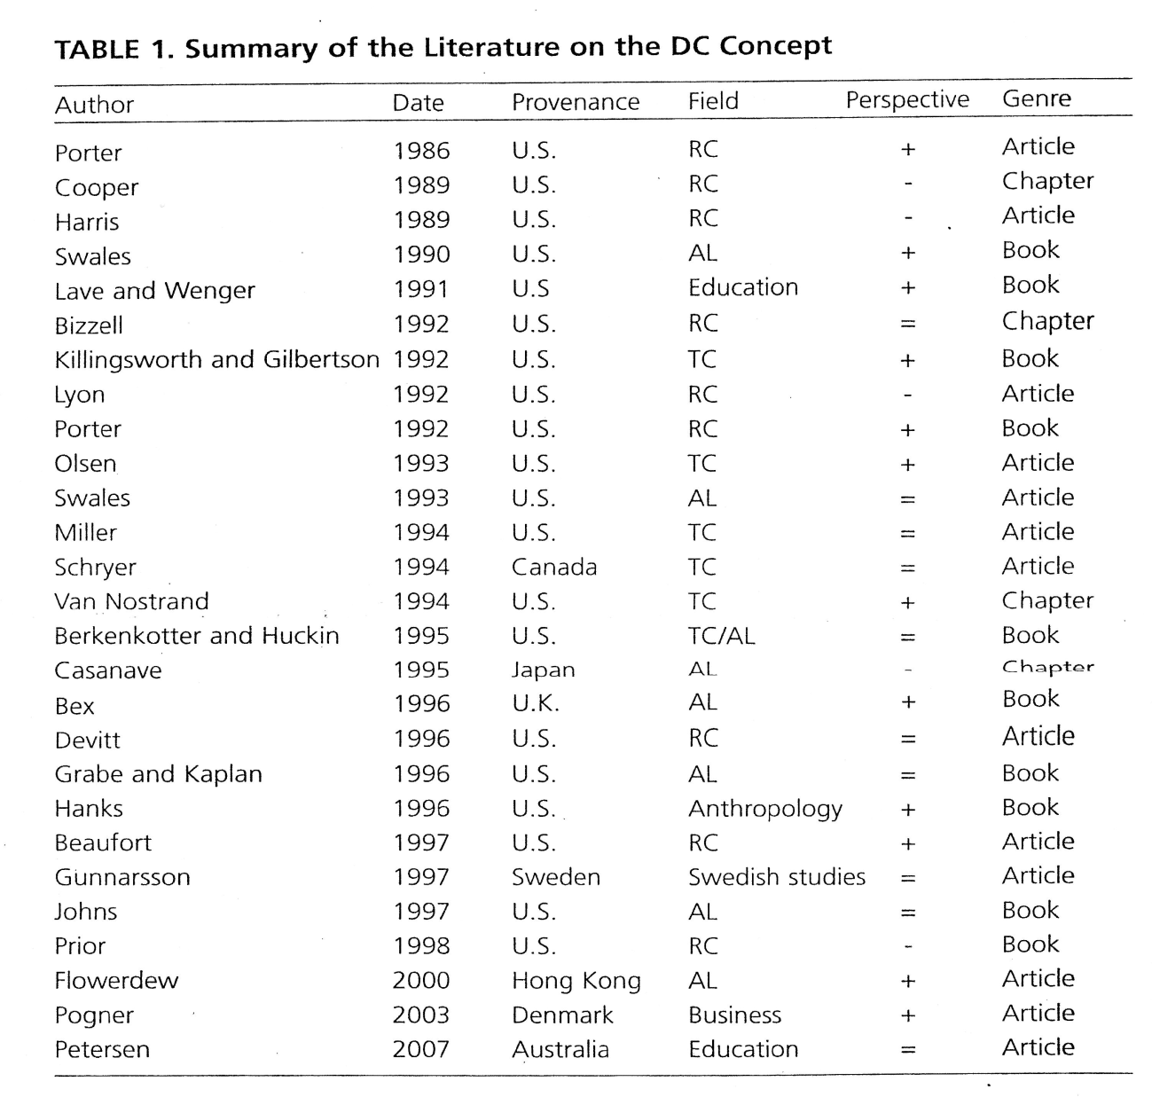

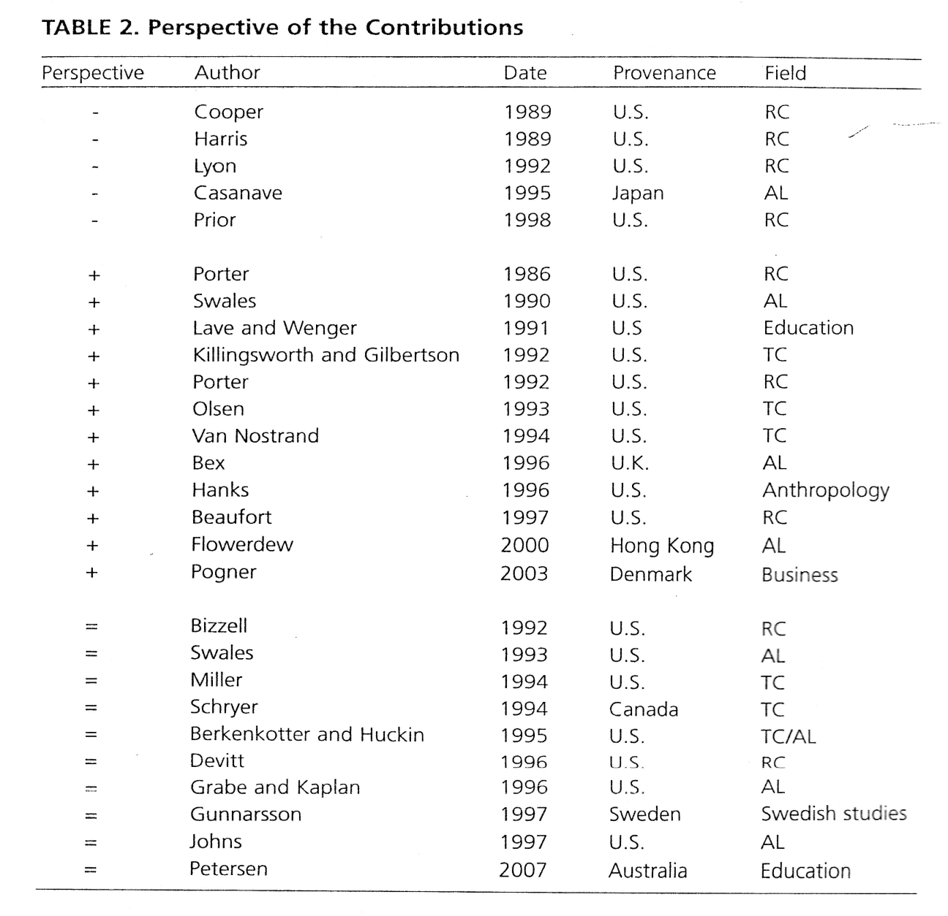

Some argumentative architectures (Weissberg & Buker, 1990)

ORDER OF CITATIONS

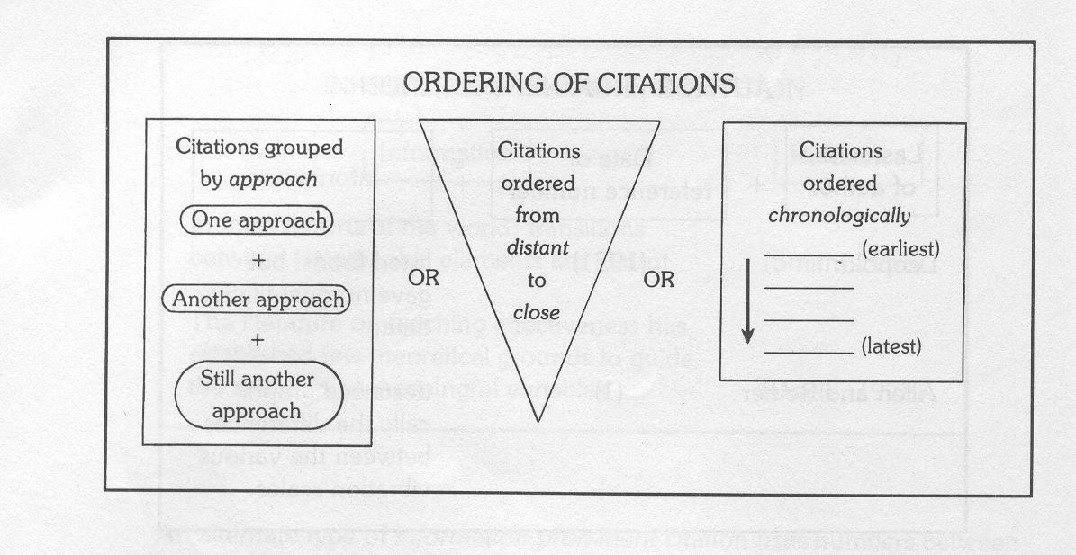

PROGRESSION OF VERB TENSES IN THE LITERATURE REVIEW (STAGE II)

